

**Ministry of Education/ ............... Directorate**

**School :……………………..**

**The Final Exam for 5th grade**

**First Semester 2023/2024**

**Subject: English Time: ...........**

**Student's Name: ……............... Date: / / 2023**

**Questions 1: Vocabulay**

**Match the words 1-5 to their meanings a-e:(3 Marks)**

|  |  |
| --- | --- |
| 1. blanket | 1. اقراط |
| 1. earrings | 1. طبيب اسنان |
| 1. dentist | 1. غطاء |

**Questions 2:**

**Circle the correct answer: (3 Marks)**

1. Themoon**is / was**a circle last night.
2. Last night, they**are / were** in bed.
3. Ali**is / was** at school yesterday.

|  |
| --- |
| …………… |
| …………… |
| …………… |

**Question 3:(3 Marks)**

Read and write **Yes** or **No**

1. It's a triangle.
2. It has four sides .
3. It has three sides.

**Question 4:**

**Complete the words with the correct letter: (3 Marks)**

1. **……… otorbike.**
2. **Gira………e .**
3. **……… ostume.**

**Question 5:**

**Read and answer: (3 Marks)**

***Hi. I'm Laila. This is the market in our town. It's near the river. It's my favorite place. I was there last Saturday. It was a beautiful day. I was happy.***

1. What's Laila'sfavourite place?

……………………………………………………………………………………………………………………………….

1. What is near the market?

………………………………………………………………………………………………………………………………

1. Was the weather nice?

……………………………………………………………………………………………………………………………….

**Question 6:**

**Choose the correct answer:(3 Marks)**

1. Yesterday, Majed**play / played** tennis.
2. 5 years ago, Ali **helped / help** me with my project.

**Questions 7:**

**Complete the following sentences with (is / are / am): (3 Marks)**

1. She …………… going to play with her friends.
2. I …………… going to paint pictures.
3. They …………… going to go to the park.

**Question 8:**

**Write the (Past Tense) of the following verbs: (3 Marks)**

1. **go: …………………………………………**
2. **phone: ……………………………………**
3. **play: ……………………………………….**
4. **take: ……………………………………….**
5. **visit: ……………………………………….**
6. **write: ……………………………………..**

**Question 9:**

**Complete the following sentences with the correct words: (4 Marks)**

|  |  |  |  |  |  |  |  |
| --- | --- | --- | --- | --- | --- | --- | --- |
| **dentist** | **firefighter** | **scientist** | **teacher** | **Fire station** | **laboratory** | **school** | **Dentist's surgery** |

1. **A ........................................ works in a .........................................**
2. **A ........................................ works in a ........................................ .**
3. **A ........................................ works in a ........................................ .**
4. **A ........................................ works in a ........................................ .**

**Question 10:**

**Answer the question: (5 Marks)**

* **What time is it?**

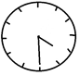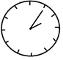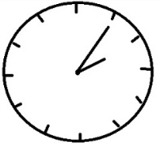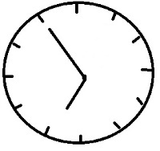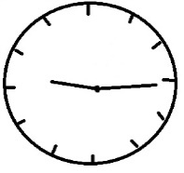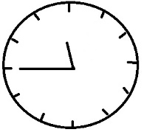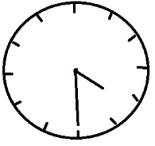

**It is ……………………………………........... It is …………………………………………………**

**Question 11:**

**Complete the spaces with the correct form of the Past Continuous:(5 Marks)**

1. Samer and I …………………………………. **(eat)** our lunch.
2. We …………………………………. **(walk)** on the street.
3. I …………………………………. **(talk)** to my teacher.
4. Samer …………………………………. **(make)** a model plane.
5. She …………………………………. **(drink)** milk.

**Question 12:**

**Complete the following table with the correct form of the comparatives and the superlatives: (3 Marks)**

|  |  |  |
| --- | --- | --- |
| **Adjective** | **Comparative** | **Superlative** |
| bright | …………………………….………… | …………………………….………… |
| careful | …………………………….………… | …………………………….………… |
| good | …………………………….………… | …………………………….………… |

The End

**تنسيق موقع الايمان التعليمي**

[**www.alemancenter.com**](http://www.alemancenter.com)